51. WAP to print Pyramid of Character.

using System;

namespace SampleCode

{

class Program

{

static void Main(string[] args)

{

int x = 15; // Total Number of Lines...

for (int i = 1; i<= x; i++)

{

for (int j = 1; j <= (x - i); j++)

Console.Write(" ");

for (int t = 1; t <i \* 2; t++)

Console.Write("a");

Console.WriteLine();

}

Console.ReadLine();

}

}

}

52.WAP to print Pyramid of Number.

using System;

namespace SampleCode

{

class Program

{

static void Main(string[] args)

{

int x = 15; // Total Number of Lines...

for (int i = 1; i<= x; i++)

{

//loop to print spaces

for (int j = 1; j <= (x - i); j++)

Console.Write(" ");

//loop to print stars

for (int t = 1; t <i \* 2; t++)

Console.Write("a");

Console.WriteLine();

}

Console.ReadLine();

}

}

}

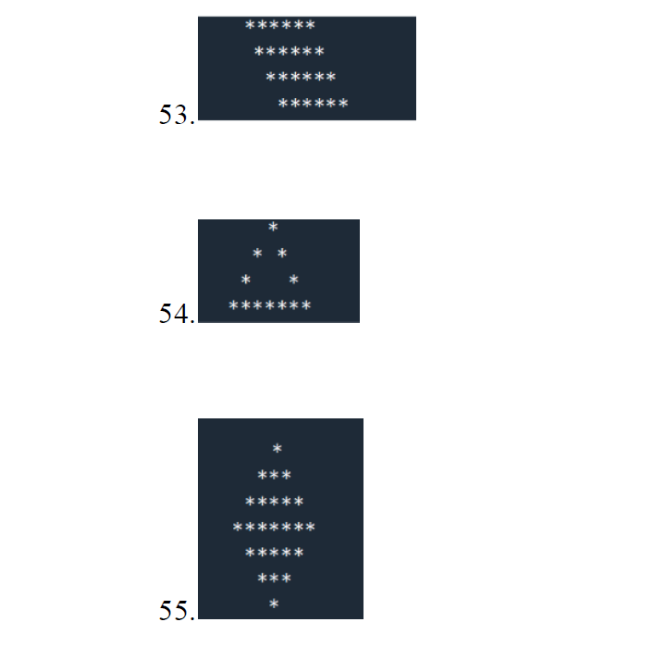

53.

class Program

{

static void Main(string[] args)

{

int size = 8;

for (int row = 1; row <= size; ++row)

{

for (int col = 1; col <= row; ++col)

{

Console.Write(" ");

}

for (int col = 1; col <= size; ++col)

{

Console.Write("\*");

}

Console.WriteLine();

}

Console.ReadLine();

}

}

54.

class Program

{

static void Main(string[] args)

{

int max = 8;

for (var i = 1; i <= max; i++)

{

for (var j = i; j < max; j++)

{

Console.Write(" ");

}

for (var j = 1; j <= (2 \* i - 1); j++)

{

if (i == max || j == 1 || j == (2 \* i - 1))

{

Console.Write("\*");

}

else

{

Console.Write(" ");

}

}

Console.WriteLine();

}

Console.ReadLine();

}

}

55.

class Program

{

static void Main(string[] args)

{

int number = 8, count = 1;

count = number - 1;

for (var k = 1; k <= number; k++)

{

for (var i = 1; i <= count; i++)

Console.Write(" ");

count--;

for (var i = 1; i <= 2 \* k - 1; i++)

Console.Write("\*");

Console.WriteLine();

}

count = 1;

for (var k = 1; k <= number - 1; k++)

{

for (var i = 1; i <= count; i++)

Console.Write(" ");

count++;

for (var i = 1; i <= 2 \* (number - k) - 1; i++)

Console.Write("\*");

Console.WriteLine();

}

Console.ReadLine();

}

}